**Checklist M&E HC API**

1. **Get list**

|  |  |
| --- | --- |
| Method | Endpoint |
| POST | /api-checklist/v1/hc/list |

|  |  |  |
| --- | --- | --- |
| Params | Data type | Description |
| Code_Prov_T | String | To filter any record under province |
| Code_OD_T | String | To filter any record under od |
| Code_Facility_T | string | To filter any record under hc |

|  |
| --- |
| Response as Json |
| [  {  "Rec_ID": 2,  "Code_Prov_T": "05",  "Code_OD_T": "0504"  "Code_Facility_T": "050406",  "VisitDate": "2021-07-10",  "CheckFrom": "2022-01",  "CheckTo": "2022-03",  "VisitorName": "Kimleng",  "VisitorSex": "M",  "Part1Score": 24,  "Part2Score": 28,  "Part3Score": 17,  "Part4Score": 9.99,  "Part5Score": 8  }  ] |

1. **Get detail**

|  |  |
| --- | --- |
| Method | Endpoint |
| POST | /api-checklist/v1/hc/detail |

|  |  |
| --- | --- |
| Params | Data type |
| Rec_ID | int |

|  |
| --- |
| Response as Json |
| {  "Rec_ID": 2,  "Code_Prov_T": "05",  "Code_OD_T": "0504",  "Code_Facility_T": "050406",  "VisitDate": "2021-07-10",  "CheckFrom": "2022-01",  "CheckTo": "2022-03",  "VisitorName": "Kimleng",  "VisitorSex": "M",  "Part1Score": 24,  "Part2Score": 28,  "Part3Score": 17,  "Part4Score": 9.99,  "Part5Score": 8,  "MissionNo": "123ABC",  "Participants": [  {  "name": "តារ",  "position": "សិករ"  },  {  "name": "នារី",  "position": "កសិករ"  }  ],  "Detail": {  "P1Q1": { "Answer": {…}, "Score": 10 },  "P1Q1_1": { "Answer": {…}, "Score": 10 },  "P1Q1_2": { "Answer": {…}, "Score": 10 },  "P1Q2": { "Answer": {…}, "Score": 10 },  "P1Q3": { "Answer": {…}, "Score": 10 },  "P1Q4": { "Answer": {…}, "Score": 10 },  "P1Q5": { "Answer": {…}, "Score": 10 },  "P1Q6": { "Answer": {…}, "Score": 10 },  "P1Q7": { "Answer": {…}, "Score": 10 },  "P2Q1": { "Answer": {…}, "Score": 10 },  "P2Q2": { "Answer": {…}, "Score": 10 },  "P2Q3": { "Answer": {…}, "Score": 10 },  "P2Q4": { "Answer": {…}, "Score": 10 },  "P2Q5": { "Answer": {…}, "Score": 10 },  "P2Q6": { "Answer": {…}, "Score": 10 },  "P3Q1": { "Answer": {…}, "Score": 10 },  "P3Q2": { "Answer": {…}, "Score": 10 },  "P3Q2_1": { "Answer": {…}, "Score": 10 },  "P3Q3": { "Answer": {…}, "Score": 10 },  "P3Q3_1": { "Answer": {…}, "Score": 10 },  "P3Q3_2": { "Answer": {…}, "Score": 10 },  "P3Q3_3": { "Answer": {…}, "Score": 10 },  "P3Q3_4": { "Answer": {…}, "Score": 10 },  "P3Q4": { "Answer": { "l1": 3, "lc": 2 }, "Score": 0 },  "P3Q5": { "Answer": {…}, "Score": 10 },  "P4": { "Answer": {…}, "Score": 10 },  "P5Q1": { "Answer": {…}, "Score": 10 },  "P5Q2": { "Answer": {…}, "Score": 10 },  "P5Q3": { "Answer": {…}, "Score": 10 },  "P5Q4": { "Answer": {…}, "Score": 10 },  "P5Q5": { "Answer": {…}, "Score": 10 },  "P6Q1": { "Answer": {…}, "Score": 10 },  "P6Q2": { "Answer": {…}, "Score": 10 },  }  } |

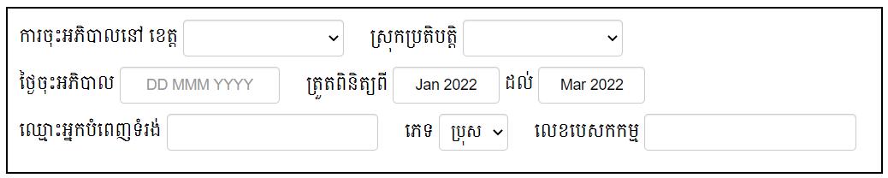

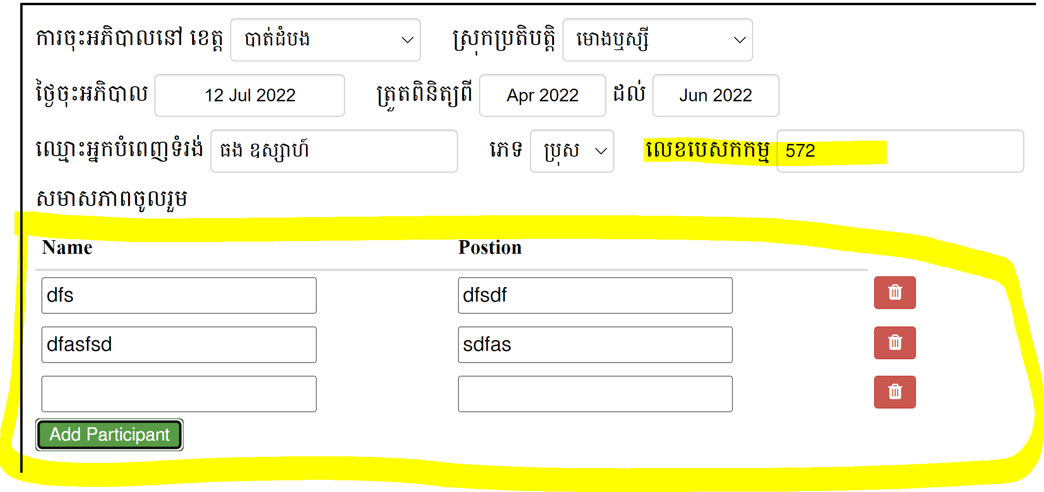

1. **Insert data & Update data**

|  |  |
| --- | --- |
| Method | Endpoint |
| POST | /api-checklist/v1/hc/update |

|  |
| --- |
| Object |
| {  "Rec_ID": 0 or 123, (0 for insert, number for update)  "Code_Prov_T": "05",  "Code_OD_T": "0504",  "Code_Facility_T": "050406",  "VisitDate": "2021-07-10",  "CheckFrom": "2022-01",  "CheckTo": "2022-03",  "VisitorName": "Kimleng",  "VisitorSex": "M",  "Part1Score": 24,  "Part2Score": 28,  "Part3Score": 17,  "Part4Score": 9.99,  "Part5Score": 8,  "MissionNo": "123ABC",  "Participants": [  {  "name": "តារ",  "position": "សិករ"  },  {  "name": "នារី",  "position": "កសិករ"  }  ],  "Detail": {  "P1Q1": { "Answer": {…}, "Score": 10 },  "P1Q1_1": { "Answer": {…}, "Score": 10 },  "P1Q1_2": { "Answer": {…}, "Score": 10 },  "P1Q2": { "Answer": {…}, "Score": 10 },  "P1Q3": { "Answer": {…}, "Score": 10 },  "P1Q4": { "Answer": {…}, "Score": 10 },  "P1Q5": { "Answer": {…}, "Score": 10 },  "P1Q6": { "Answer": {…}, "Score": 10 },  "P1Q7": { "Answer": {…}, "Score": 10 },  "P2Q1": { "Answer": {…}, "Score": 10 },  "P2Q2": { "Answer": {…}, "Score": 10 },  "P2Q3": { "Answer": {…}, "Score": 10 },  "P2Q4": { "Answer": {…}, "Score": 10 },  "P2Q5": { "Answer": {…}, "Score": 10 },  "P2Q6": { "Answer": {…}, "Score": 10 },  "P3Q1": { "Answer": {…}, "Score": 10 },  "P3Q2": { "Answer": {…}, "Score": 10 },  "P3Q2_1": { "Answer": {…}, "Score": 10 },  "P3Q3": { "Answer": {…}, "Score": 10 },  "P3Q3_1": { "Answer": {…}, "Score": 10 },  "P3Q3_2": { "Answer": {…}, "Score": 10 },  "P3Q3_3": { "Answer": {…}, "Score": 10 },  "P3Q3_4": { "Answer": {…}, "Score": 10 },  "P3Q4": { "Answer": { "l1": 3, "lc": 2 }, "Score": 0 },  "P3Q5": { "Answer": {…}, "Score": 10 },  "P4": { "Answer": {…}, "Score": 10 },  "P5Q1": { "Answer": {…}, "Score": 10 },  "P5Q2": { "Answer": {…}, "Score": 10 },  "P5Q3": { "Answer": {…}, "Score": 10 },  "P5Q4": { "Answer": {…}, "Score": 10 },  "P5Q5": { "Answer": {…}, "Score": 10 },  "P6Q1": { "Answer": {…}, "Score": 10 },  "P6Q2": { "Answer": {…}, "Score": 10 },  }  } |

|  |
| --- |
| Response as Json (Insert data only) |
| { "Rec_ID": 1 } |

1. **Delete data**

|  |  |
| --- | --- |
| Method | Endpoint |
| POST | /api-checklist/v1/hc/delete |

|  |  |
| --- | --- |
| Params | Data type |
| Rec_ID | int |

1. **Get additional data**

|  |  |
| --- | --- |
| 1. Method | Endpoint |
| POST | /api-checklist/v1/hc/misdata |

|  |  |
| --- | --- |
| Params | Data type |
| Code_Facility_T | String |

|  |
| --- |
| Response as Json |
| {  "vmw": 33,  } |

vmw